Parish bulletin announcement
Amazing Movie Coming To Our Parish
“insert date and time”
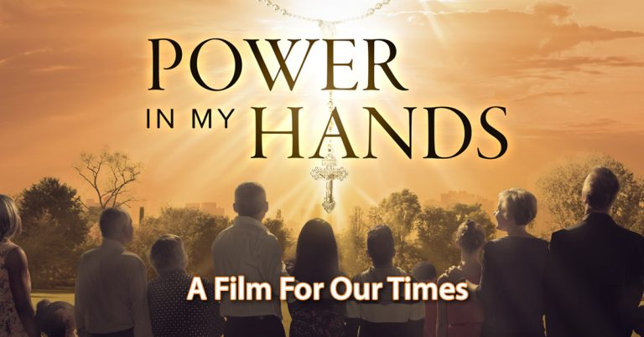
A story of Hope and the Power of Prayer
81 minute film for all ages
Our parish has the opportunity to experience the rosary like never before. Power In My Hands, featuring a 13 member all-star cast, conveys the timeless message of hope and the power of the Rosary in a way that speaks to the heart of modern viewers. Don’t miss this opportunity to transform your life! Find out more about the film at powerinmyhandsthemovie.com.
Don’t Miss Your Chance To See Power In My Hands!
This film has captivated audiences worldwide and inspired people of all ages to encounter Jesus Christ through the rosary. This is a unique opportunity for our parish to come together and share in the beauty and power of this devotion. Join us and invite a friend!

